Practical: -8

Aim: - implement outer join, inner join and self-join operations.

SQL> create table customer (Ac_id int primary key, c_name varchar (10), address varchar (100));

Table created.

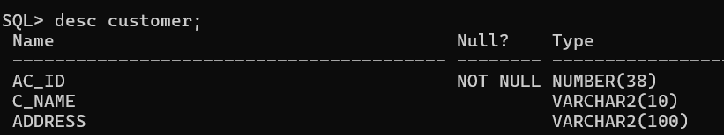

SQL> create table Orders (Bo_id int primary key, Bo_name varchar (20), Ac_id int, foreign key (Ac_id) references customer (Ac_id) on delete cascade);

Table created.

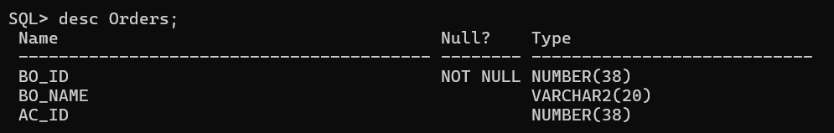

SQL> insert into customer (Ac_id, c_name, address) values (1, 'Ramu’, 'New York');

SQL> insert into customer (Ac_id, c_name, address) values (2, 'Raju', 'Delhi');

SQL> insert into customer (Ac_id, c_name, address) values (3, 'Anshu’, 'ap');

SQL> insert into customer (Ac_id, c_name, address) values (4, 'Uma', 'ts');

SQL> insert into Orders (Bo_id, Bo_name, Ac_id) values (101, 'Ramu’, 1);

SQL> insert into Orders (Bo_id, Bo_name, Ac_id) values (102, 'raja' ,2);

SQL> insert into Orders (Bo_id, Bo_name, Ac_id) values (103, 'Anshu' ,3);

SQL> insert into Orders (Bo_id, Bo_name, Ac_id) values (104, 'Uma' ,4);

SQL>select * from customer;

SQL>select * from orders;

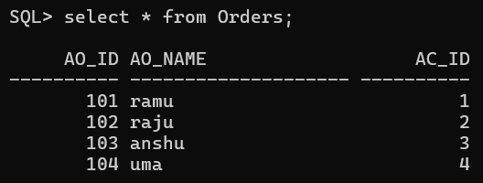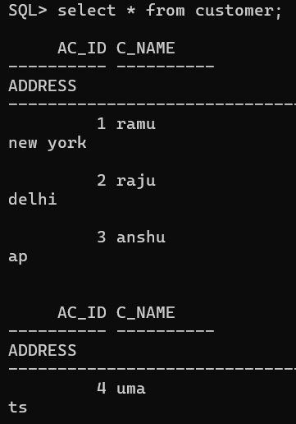

SQL> SELECT c. Ac_id, c_name, c. address, o. Bo_id, o. Bo_name FROM customer c LEFT JOIN Orders o ON c. Ac_id = o. Ac_id;

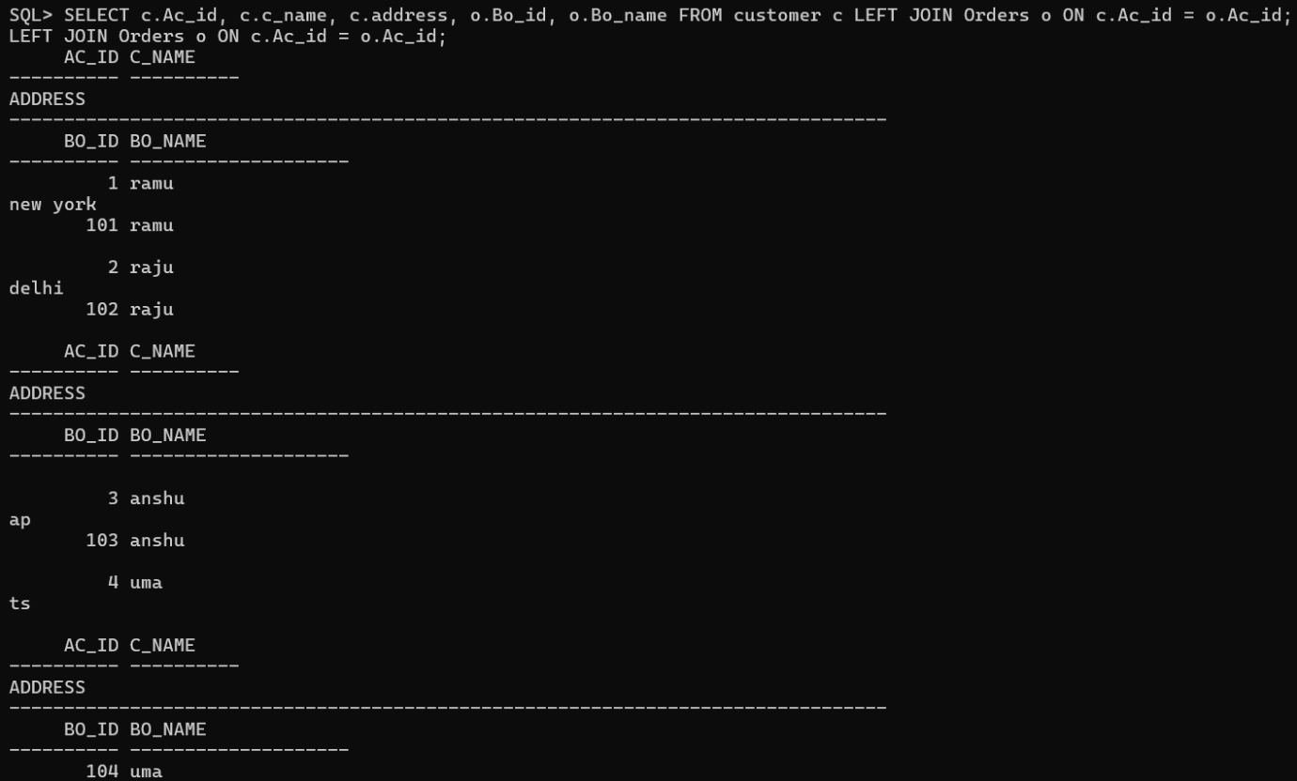

SQL> SELECT c. Ac_id, c_name, c. address, o. Bo_id, o. Bo_name FROM customer c RIGHT JOIN Orders o ON c. Ac_id = o. Ac_id;

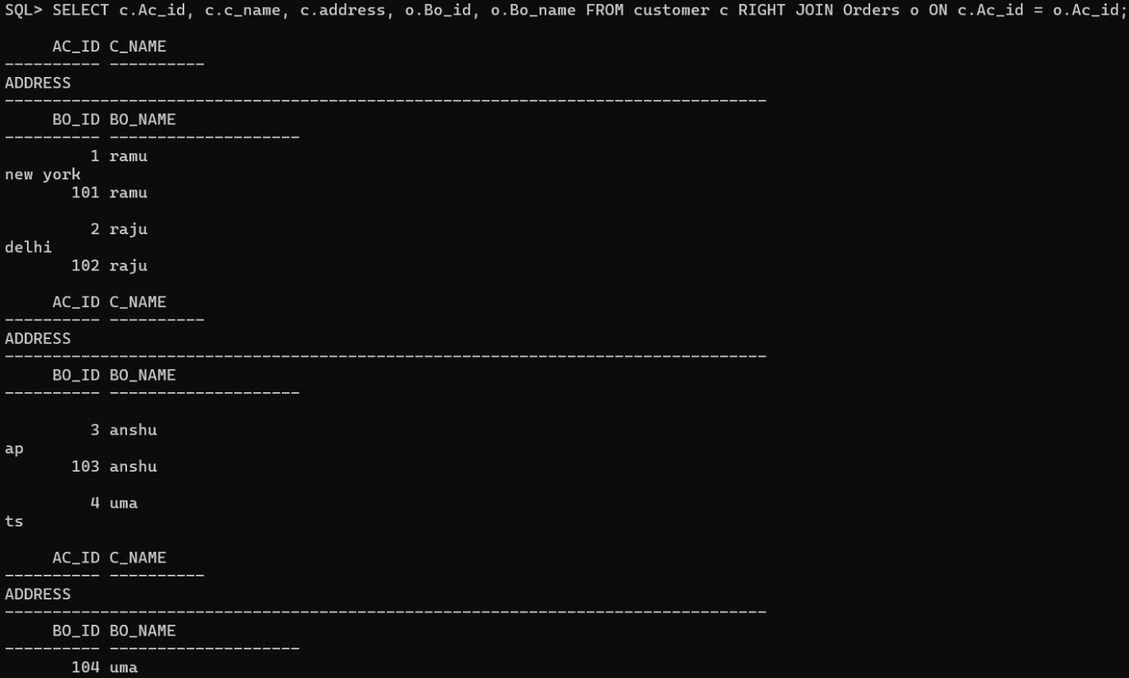

SQL> SELECT c. Ac_id, c_name, c. address, o. Bo_id, o. Bo_name FROM customer c INNER JOIN Orders o ON c. Ac_id = o. Ac_id;

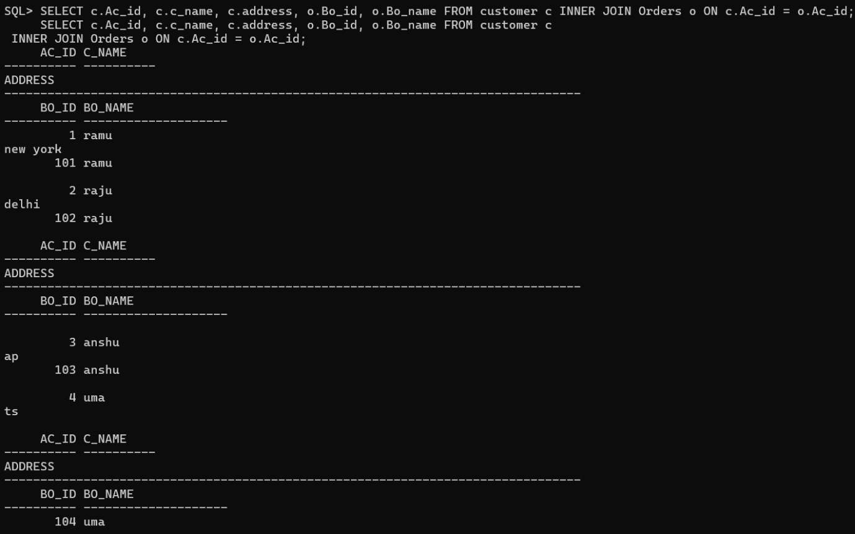

SQL> SELECT c. Ac_id, c. c_name, c. address, o. Bo_id, o. Bo_name FROM customer c LEFT JOIN Orders o ON c. Ac_id = o. Ac_id Where o. Bo_id is null;

no rows selected



SQL> SELECT c. Ac_id, c_name, c. address, o. Bo_id, o. Bo_name

2 FROM customer c

3 RIGHT JOIN Orders o ON c. Ac_id = o. Ac_id

4 WHERE c. Ac_id IS NULL;

